Tasks
1. Setup Kafka standalone / Cluster

Standalone

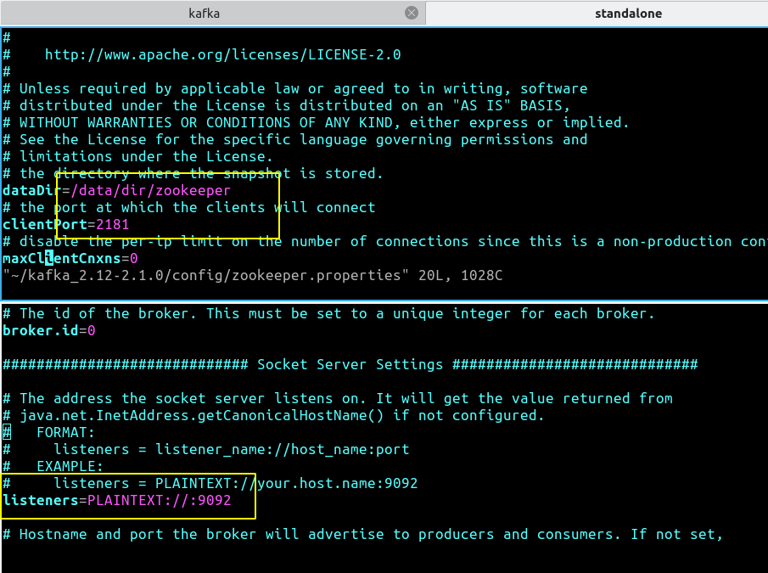
Cluster

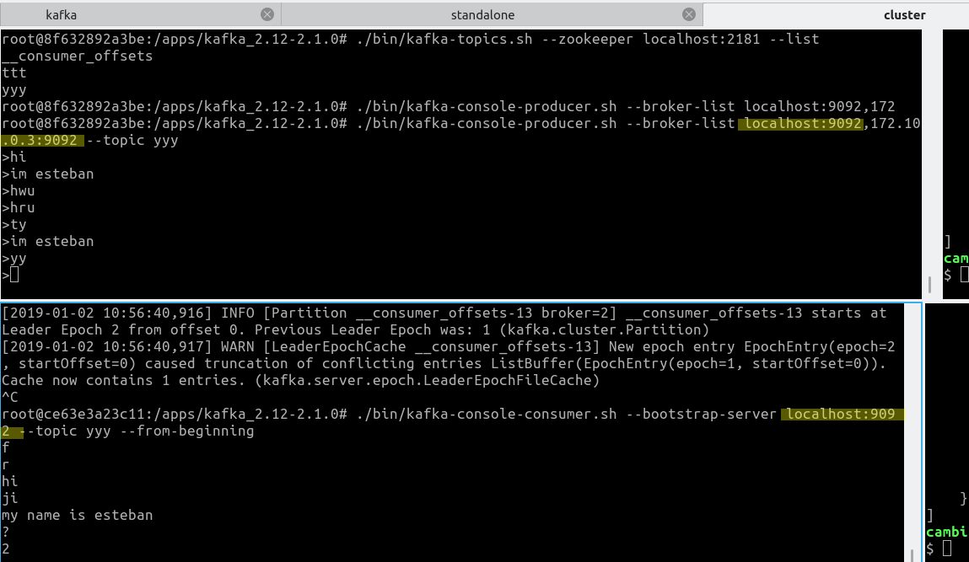

2. Create topic using command line interface

3. You must write Kafka Producer in your preferred language and produce all available products to Kafka [Json format]

Producer:
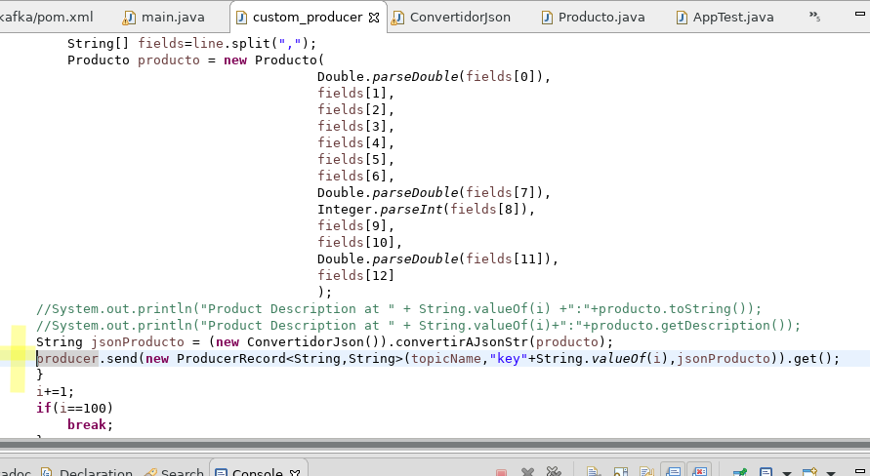

4. You must also monitor, publish product rate on Kafka (e.g. 100 products / second)

Single Partition/1Thread
Product Event | 10k | 100k | 500k | 1000k | 2000k
Produce Time(ms) | 73320 | 337415 | - | - | -

Single Partition/2Thread
Product Event | 10k | 100k | 500k | 1000k | 2000k
Produce Time(ms) | 40819 | 198580 | - | - | -

Multiple partition conf


Multiple Partition/1Thread

Product Event | 10k | 100k | 500k | 1000k | 2000k
Produce Time(ms) | 60011 | 290053 | - | - | -

Multiple Partition/2Thread
Product Event | 10k | 100k | 500k | 1000k | 2000k
Produce Time(ms) | 29820 | 185509 | - | - | -

5. Using command line, you should also check if data is able to publish on Kafka

I’m using kafka console consumer to check the data is being published.

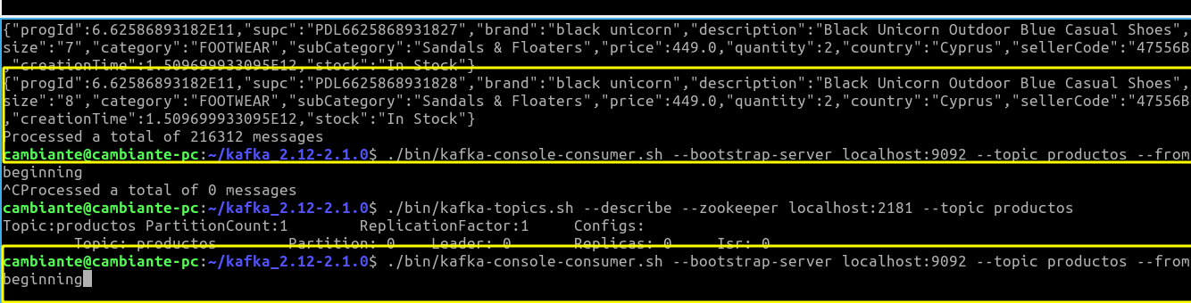

6. You must have a monitor thread which will print stats of “publishing rate of events per minute and CPU stats

./bin/kafka-producer-perf-test.sh --topic productos3 --num-records 50 --throughput 10 --producer-props bootstrap.servers=localhost:9092 key.serializer=org.apache.kafka.common.serialization.StringSerializer value.serializer=org.apache.kafka.common.serialization.StringSerializer --record-size 1
50 records sent, 10.044194 records/sec (0.00 MB/sec), 138.28 ms avg latency, 2263.00 ms max latency, 12 ms 50th, 211 ms 95th, 2263 ms 99th, 2263 ms 99.9th.

7. Publishing products in multithreaded environment

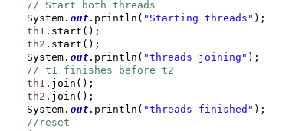
Processing batch of rows int wo threads:

8. You must also configure Kafka properties, i.e. retry count.

Increase this one if there is latency



9. Running multiple instances of Kafka Producer and observe the
behaviour

CPU usage is high.
10. Observe CPU usage and accordingly configure Java heap variables

